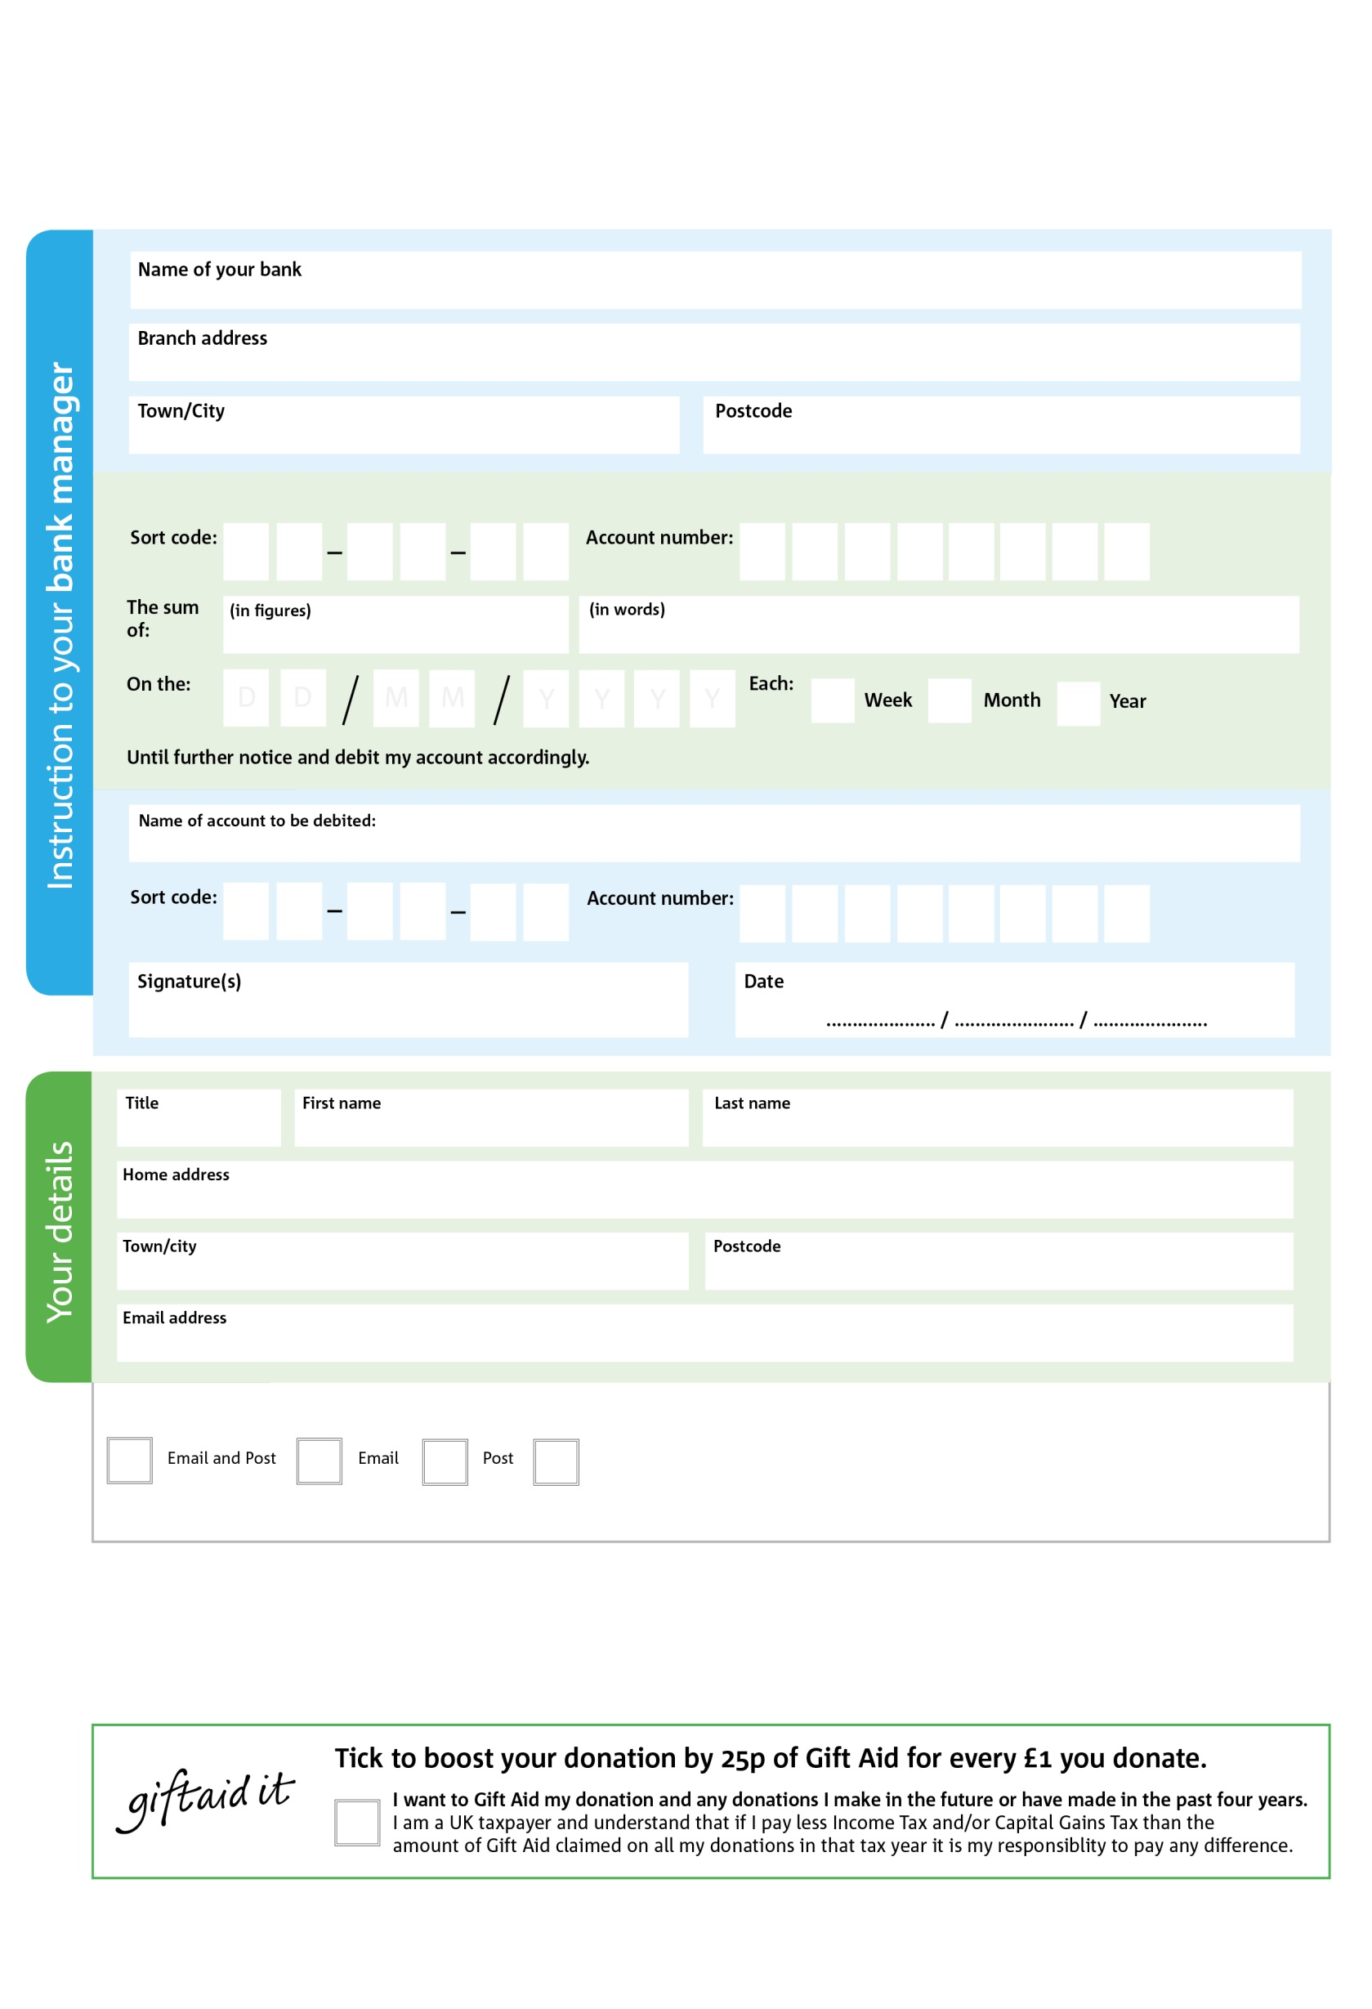

**Standing Order Mandate**

**info@prestatynmeliden.foodbank.org.uk**

Please pay Prestatyn & Meliden Foodbank,

POSTAL ADDRESS: Prestatyn & Meliden Foodbank, Alive Church, 200 Victoria Road, Prestatyn, Denbighshire, LL19 7TL

Reg. Charity No: 1052199| Reg. in England & Wales

1

V

5

V

3

V

9

V

9

V

4

V

1

V

5

V

**Please pass this form onto the foodbank, using the foodbank’s address at the bottom, who will save a copy for their records.   
They will then send it onto your named bank or building society.**

2

2

7

30

0

40

We would love to keep you up to date with information about Prestatyn & Meliden Foodbank. Please tick your preference:

You can change your preferences any time by contacting us on 07722749773 or emailing us at info@prestatynmeliden.foodbank.org.uk

I do not wish to receive future communications from Prestatyn & Meliden Foodbank

**Data protection**

*'Prestatyn & Meliden Foodbank is committed to protecting your privacy and will process your personal data in accordance with current Data Protection legislation. Prestatyn & Meliden Foodbank collects information to keep in touch with you and supply you with information relating to our work. To unsubscribe from our newsletter, send a message to the email address above with the word unsubscribe in the subject line. A full data privacy statement for financial donors is available from the foodbank on request.’*

You can change your preferences any time by contacting us on XXXXXXXXXXX or emailing us at XXXX@XXXXXXXXXX.foodbank.org.uk

I do not wish to receive future communications from XXXXXX Foodbank