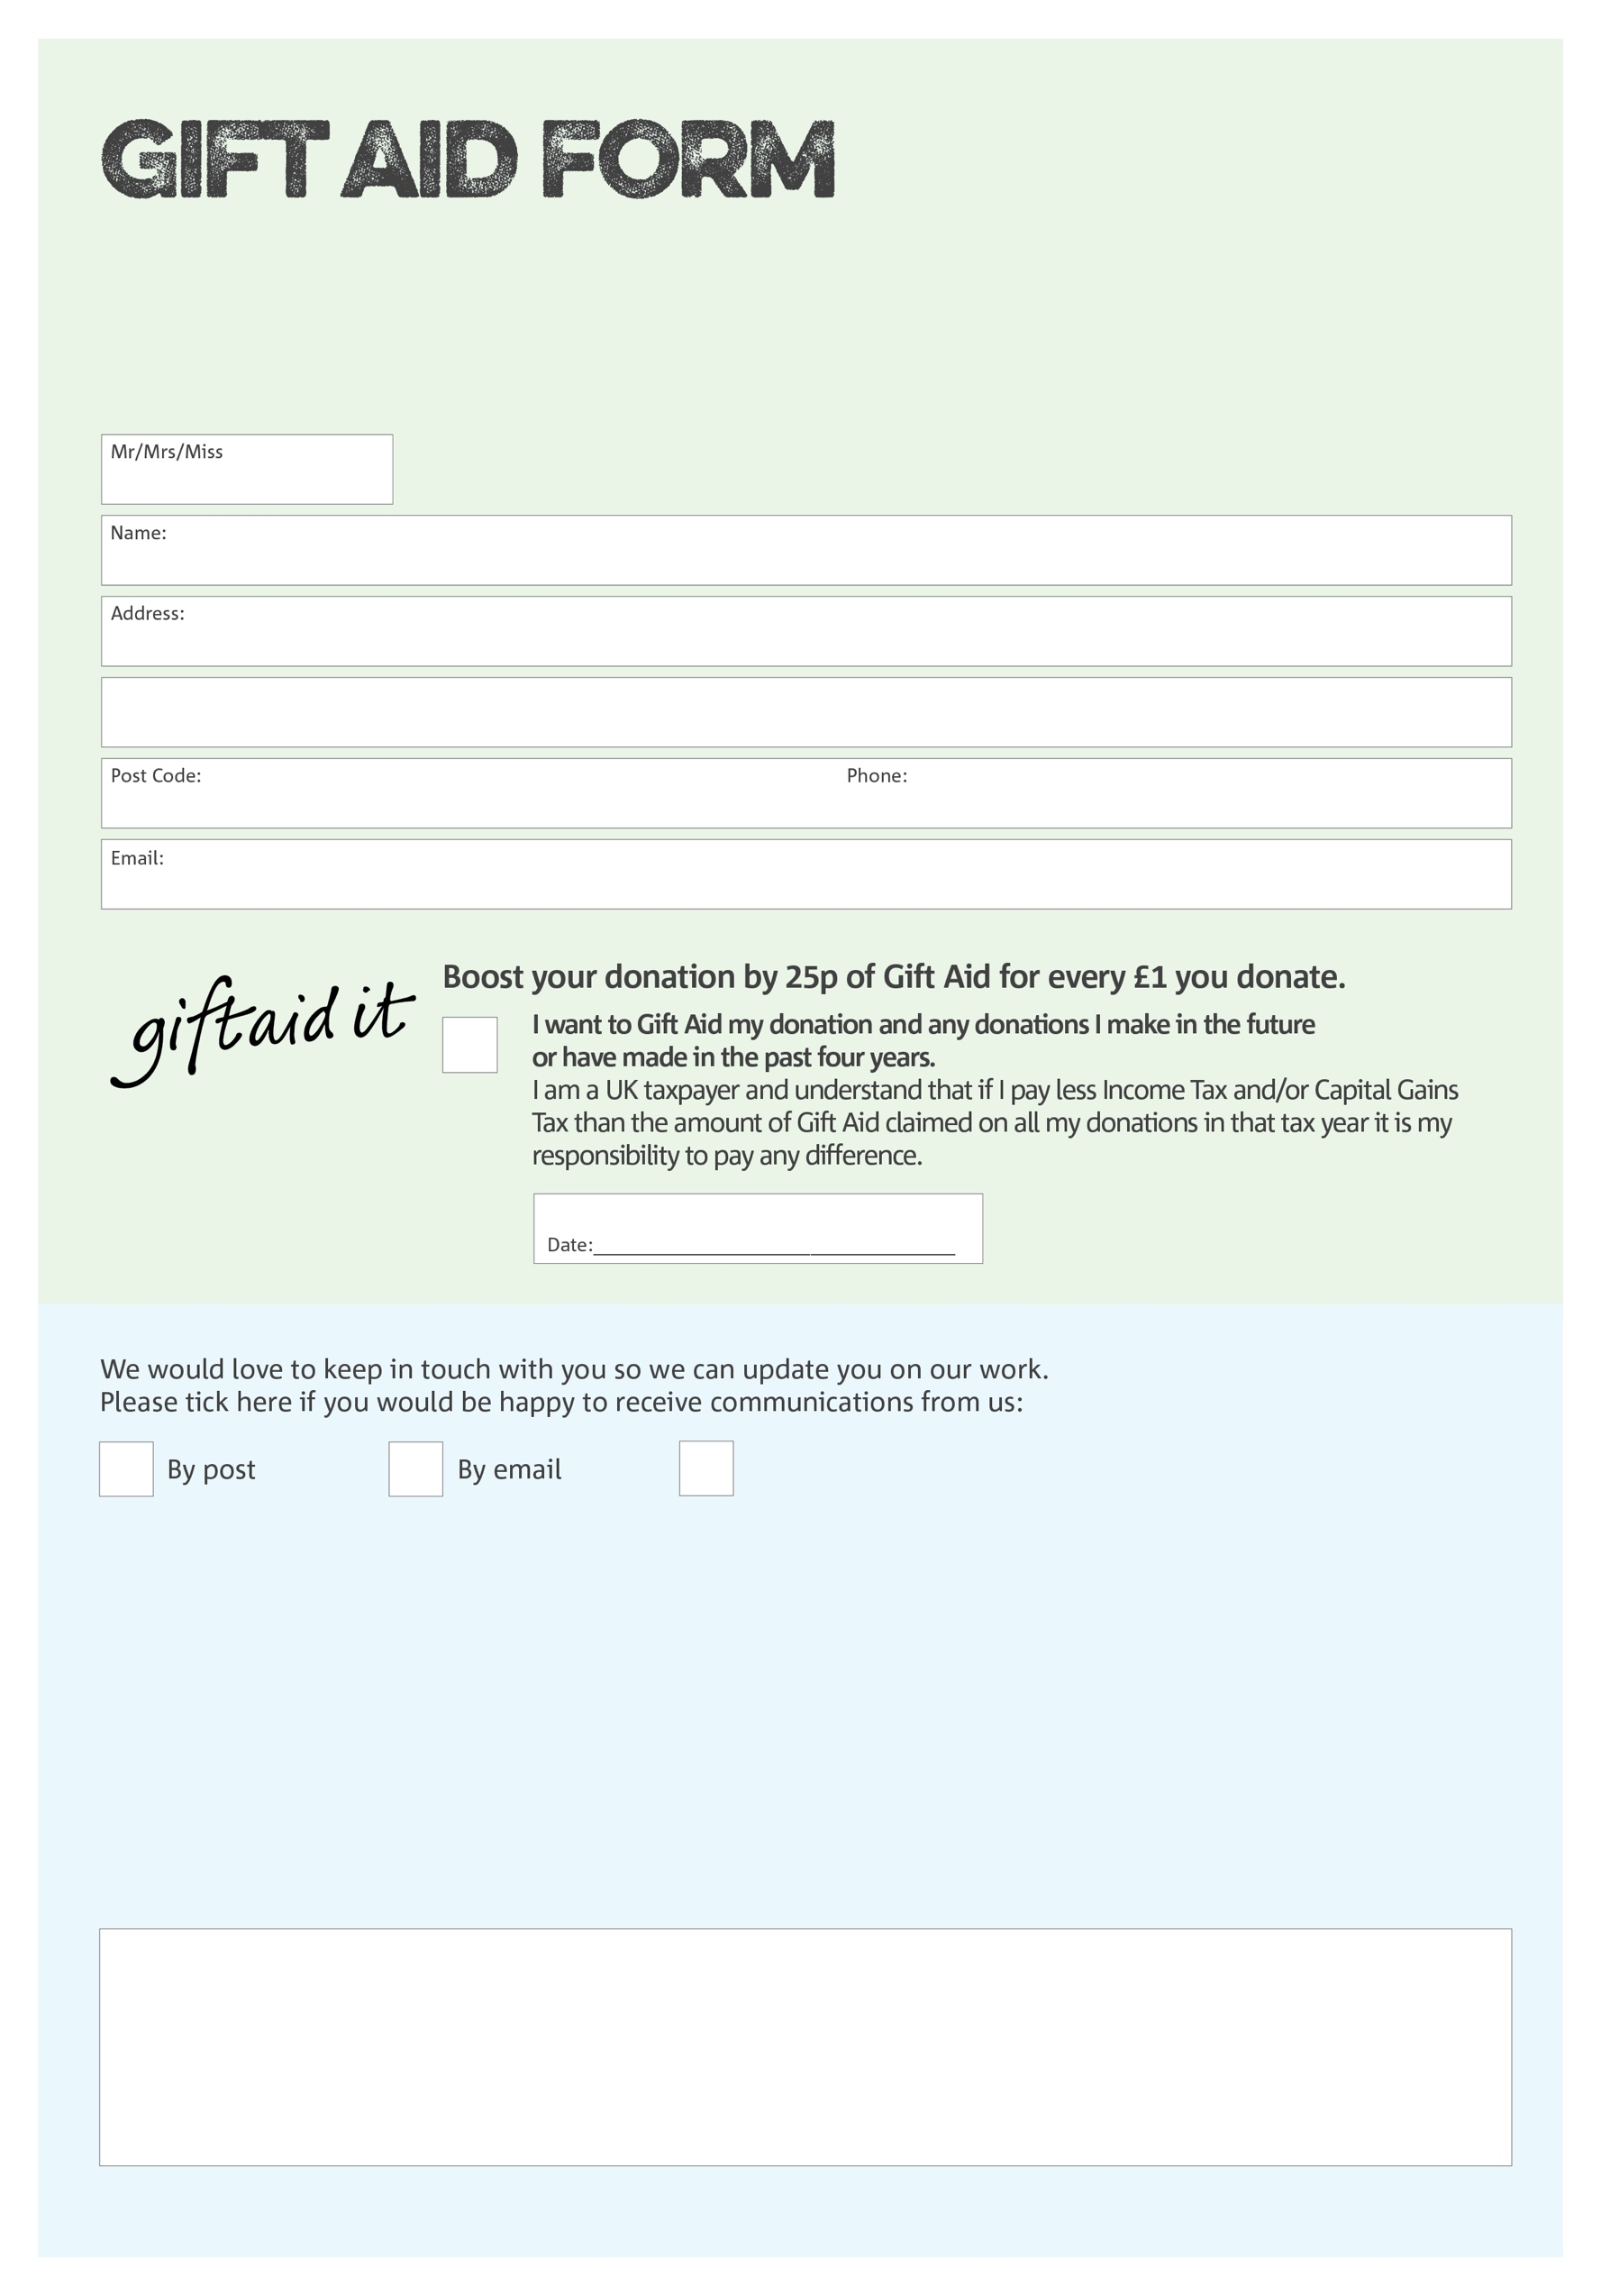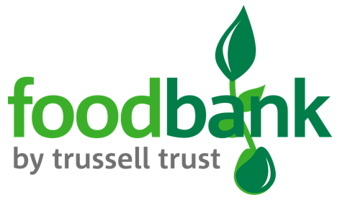

By filling in this form Prestatyn & Meliden Foodbank will receive an extra 25p for every £1 you give at no extra cost to you. Thank you!

**Data protection**

*'Prestatyn & Meliden Foodbank is committed to protecting your privacy and will process your personal data in accordance with current Data Protection legislation. Prestatyn & Meliden Foodbank collects information to keep in touch with you and supply you with information relating to our work. To unsubscribe from our newsletter, send a message to the email address above with the word unsubscribe in the subject line. A full data privacy statement for financial donors is available from the foodbank on request.’*

You can change your preferences any time by contacting us on 07722749773 or emailing us at info@prestatynmeliden.foodbank.org.uk

I do not wish to receive future communications from Prestatyn & Meliden Foodbank

We would love to know why you have chosen to donate to Prestatyn & Meliden Foodbank. If you would like to share your motivation let us know below:

Charity Number 1052199. Registered in England & Wales